9Tap Project: Push/Pull Standard Operating Procedure

Branch Creation and Syncing
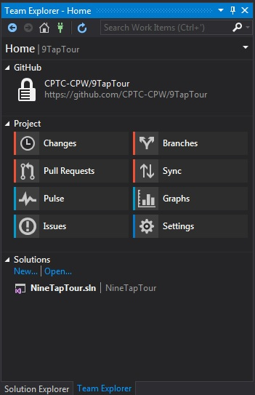
- All code must be entered on a branch. Do not code on master (even your own copy).
  - Use Visual Studio to clone or sync the master copy of 9Tap. Once set up, on the Team Explorer tab, click Branches. Right Click master under 9Tap Tour and select Create Local Branch From… Enter a branch name and ensure Checkout branch is selected.
  - Use this branch to code an individual feature, enhancement, bug fix or addition. You can make multiple branches for working on multiple issues or code changes concurrently. When you code, ensure you are working on the proper branch.
  - In order for your branch to show up on GitHub, select that branch from your Branches section (under Team Explorer tab), right click and select Publish Branch. This places the branch into the branches windows in GitHub.
  - After you code, ensure you save your changes on the appropriate branch. (See below) Do not save to master.
    - From the Team Explorer tab, click Changes. A Commit note is required. Be as detailed as necessary, but a general overview of the changes you’ve made is required.
    - Click Commit. A message should appear, click Sync in the message to sync changes to the GitHub branch.
    - This will take you to the Synchronization area. The number next to the header Outgoing Commits tells you how many changes you have made. Click Push under Outgoing Commits. Your changes are now viewable under the branch on GitHub.

Initiating a Pull Request
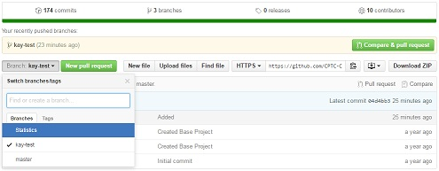
- From Visual Studio, click Pull Requests OR navigate to the 9Tap Tour project on GitHub.
- Click New Pull Request.
- Ensure your information is correct:
  - Base should be set to master and compare is set to your branch,
    - Ensure you properly document the changes in the textboxes provided. Comments are required.
- Click the big green button labeled Create pull request.

Pushing to Master
- Only the Tech Lead and Instructors may Push to master.
- The Tech Lead is responsible for conflict resolution; when in doubt the Tech Lead will refer to the Instructors for assistance.
  - Team members should pay close attention to their pull requests; the Tech Lead may request alterations to the pull request.
    - The Tech Lead may issue a standby via comment (holding the pull request for later).
    - The Tech Lead must issues comments when a pull request is denied. Please be as detailed as possible.
- When conflicts have been resolved, the Tech Lead or Instructors will Push the changes to master and update the Project Manager as to the changes.
  - The Project Manager will instruct the team at the beginning of the next class period to sync with the updated version of master.
- After a successful merge, the Tech Lead must update GitHub Issues for that feature, enhancement or bug. Existing tags should be cleared and “Ready to Test” should be added. The existing issue should then be reassigned to a Tester.

